7 Habits of Highly Effective Teens

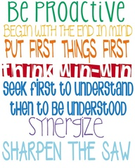

Hoover Staff Lighthouse Team

Jodi Bauler – 8th Literacy Mike Fisher- Principal
Kayla Irwin- Leader in Me Deb Kisch – 7th Literacy Mary Loomer- 7th Science Kelly Nelson- Project Lead the Way Jeremy Prouty- Expanding Learning Dan Reisner – 8th Math Macaulley Whitlock- Orchestra

